Functional Design Document

Download option from Document List, Minified Document List & Document Viewer

Table of Contents

Download option from Document List, Minified Document List & Document Viewer 2

Current Challenge: 2

User Story 1: Download option in Document List’s toolbar 3

Mock Up: 3

Conditions: 3

Acceptance Criteria 4

User Story 2: Download option in Minified Document List’s toolbar 5

Mock Up: 5

Conditions: 5

Acceptance Criteria 6

User Story 3: Download option in Embedded/Standalone Document Viewer 7

Mock Up: Embedded Document Viewer 7

Mock Up: Standalone Document Viewer 8

Conditions: 8

Acceptance Criteria 9

# Download option from Document List, Minified Document List & Document Viewer

As a PaperSave user, I may need the ability to download documents either from Document List, Minified Document List or from Document Viewer

### Current Challenge:

The user has no way download the Workflow Items from the Document List, Minified Document List or from Document Viewer.

# User Story 1: Download option in Document List’s toolbar

Download option will be available within the Document List’s toolbar, refer to below mock up.

### Mock Up:

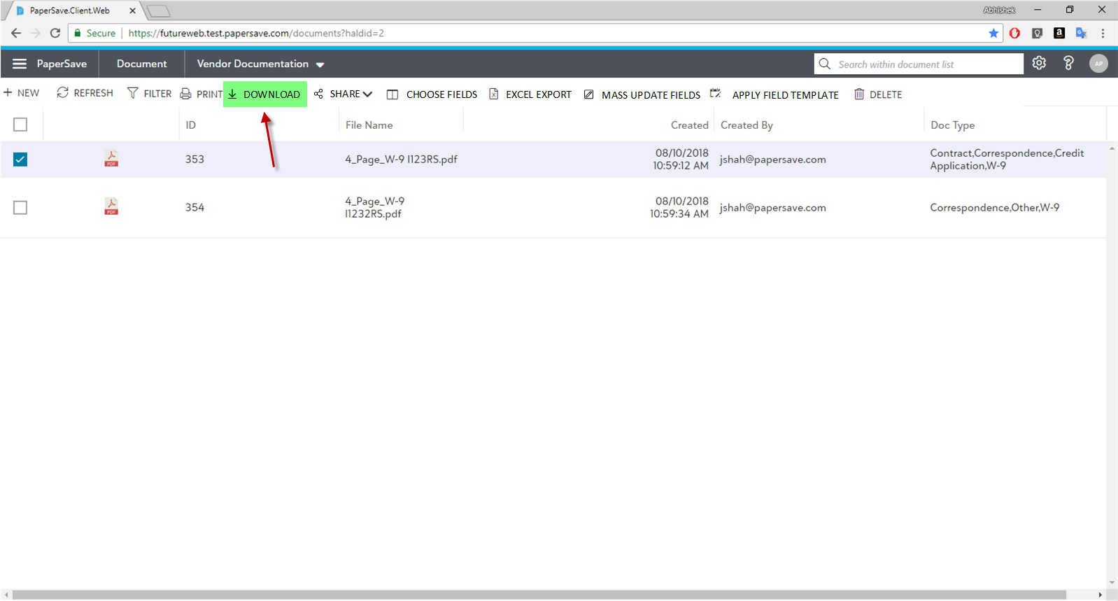

### Conditions:

#### Condition 1: Enabling Download button

* Download button will get enable if the below condition is met:
  + If at least one or more documents are selected.

#### Condition 2: Delete mechanism

* If the user has selected only a single document, then upon clicking on the “Download” button, it should then initiate a browser download operation as mentioned below:
  + The downloaded file should have the below naming convention:
    - *[DOCUMENTID] + “ - “ + [CURRENT DATE AND TIME]****.fileextension***
      * ***For example:*** *if the Document ID = 7596 and the file type is PDF, then the downloaded file will have the name as:*
        + ***7596 - 9/6/2018 1:50 PM.PDF***
* If the user has selected multiple documents, then upon clicking on the “Download” button, it should then initiate a browser download operation as mentioned below:
  + It should generate a zip file containing all the selected workflow items with the name of the zip file as:
    - *“Documents of “ + [DOCUMENTTYPENAME] + “ document type - “ + CURRENT DATE AND TIME.zip*
      * ***For example:*** *if the document type name = Purchases, then the downloaded zip file will have the name as:*
        + ***Documents of Purchases document type -******9/6/2018 3:00 PM.zip***
  + Each document’s name within the zip file should have the below naming convention:
    - *[DOCUMENTID] + “ - “ + CURRENT DATE AND TIME.****fileextension***
      * ***For example:*** *if the Document ID = 7596 and the file type is PDF, then the downloaded file will have the name as:*
        + ***7596 - 9/6/2018 1:50 PM.PDF***
* Upon successful or unsuccessful completion of the Delete operation:
  + It should deselect the selected workflow items.

#### Condition 3: Ability to access document from download directory

* The user must have the ability to find and successfully open document from default download directory

### Acceptance Criteria

#### Acceptance Criteria 1: Verifying Conditions

Verify all the conditions mentioned above. (Condition 1 to 3)

# User Story 2: Download option in Minified Document List’s toolbar

Download option will be available within the Minified Document List’s toolbar, refer to below mock up.

### Mock Up:

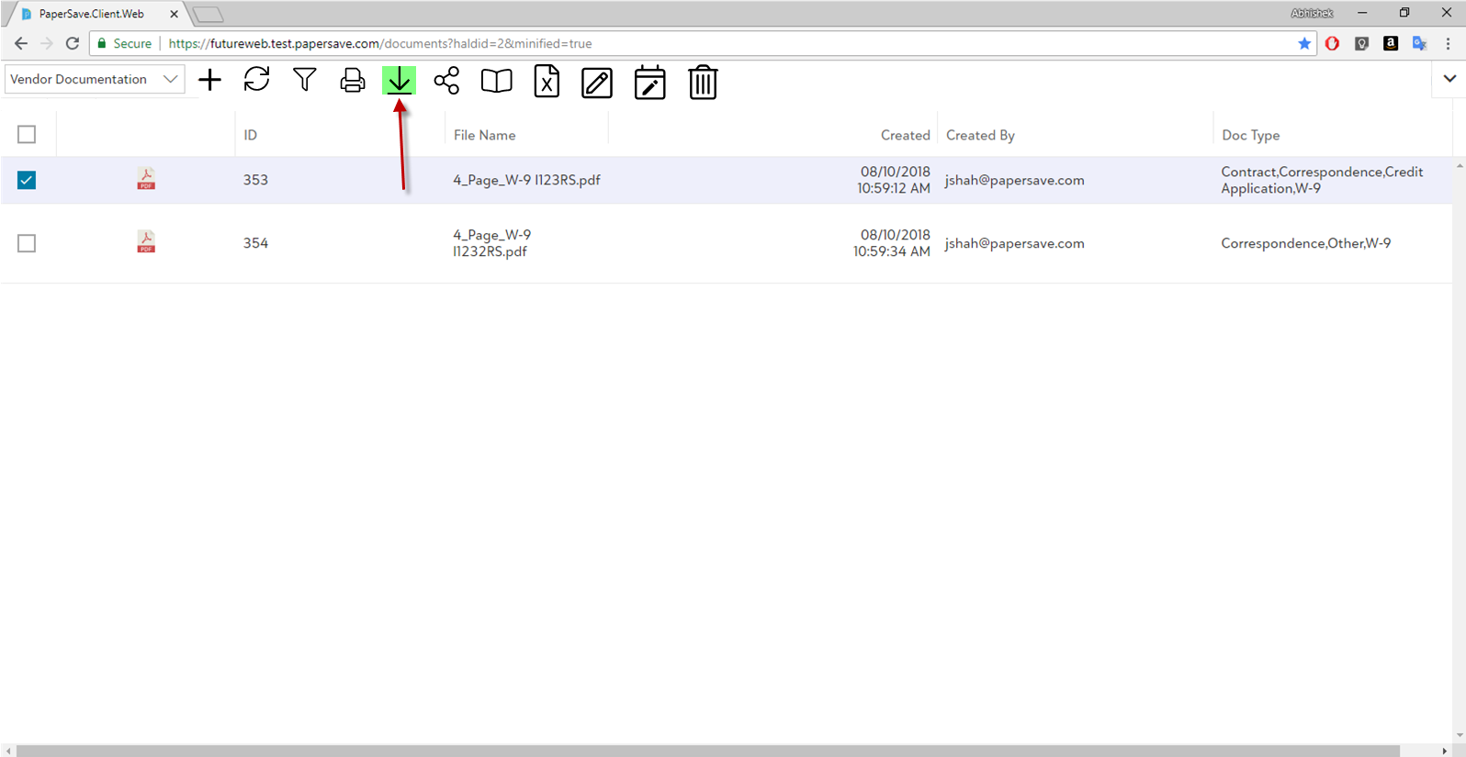

### Conditions:

#### Condition 1: Enabling Download button

* Download button will get enable if the below condition is met:
  + If at least one or more documents are selected.

#### Condition 2: Download mechanism

* If the user has selected only a single document, then upon clicking on the “Download” button, it should then initiate a browser download operation as mentioned below:
  + The downloaded file should have the below naming convention:
    - *[DOCUMENTID] + “ - “ + [CURRENT DATE AND TIME]****.fileextension***
      * ***For example:*** *if the Document ID = 7596 and the file type is PDF, then the downloaded file will have the name as:*
        + ***7596 - 9/6/2018 1:50 PM.PDF***
* If the user has selected multiple documents, then upon clicking on the “Download” button, it should then initiate a browser download operation as mentioned below:
  + It should generate a zip file containing all the selected workflow items with the name of the zip file as:
    - *“Documents of “ + [DOCUMENTTYPENAME] + “ document type - “ + CURRENT DATE AND TIME.zip*
      * ***For example:*** *if the document type name = Purchases, then the downloaded zip file will have the name as:*
        + ***Documents of Purchases document type -******9/6/2018 3:00 PM.zip***
  + Each document’s name within the zip file should have the below naming convention:
    - *[DOCUMENTID] + “ - “ + CURRENT DATE AND TIME.****fileextension***
      * ***For example:*** *if the Document ID = 7596 and the file type is PDF, then the downloaded file will have the name as:*
        + ***7596 - 9/6/2018 1:50 PM.PDF***
* Upon successful or unsuccessful completion of the Delete operation:
  + It should deselect the selected workflow items.

#### Condition 3: Ability to access document from download directory

* The user must have the ability to find and successfully open document from default download directory

### Acceptance Criteria

#### Acceptance Criteria 1: Verifying Conditions

Verify all the conditions mentioned above. (Condition 1 to 3)

# User Story 3: Download option in Embedded/Standalone Document Viewer

Download option will be available within the Embedded and Standalone Document Viewer’s toolbar, refer to below mock ups.

### Mock Up: Embedded Document Viewer

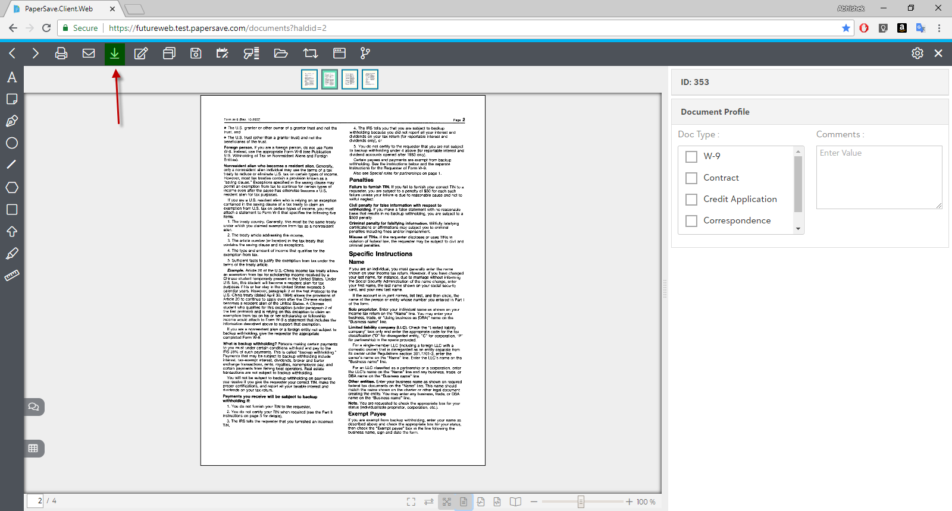

### Mock Up: Standalone Document Viewer

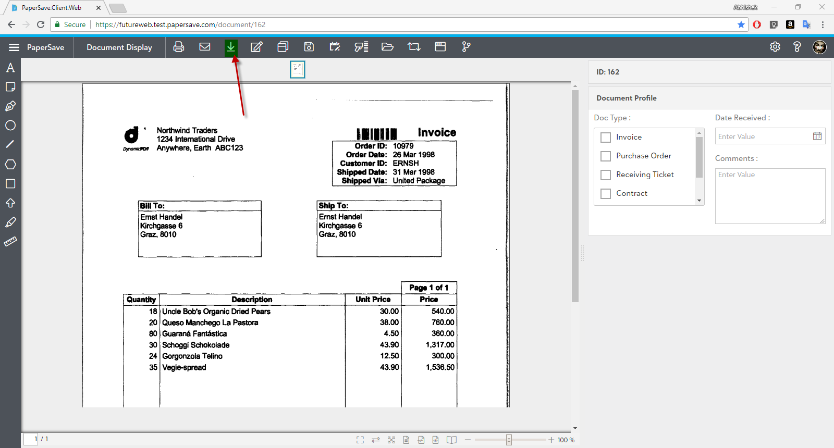

### Conditions:

#### Condition 1: Download mechanism

* When the user clicks on the “Download” button, it should then initiate a browser download operation as mentioned below:
  + The downloaded file should have the below naming convention:
    - *[DOCUMENTID] + “ - “ + [CURRENT DATE AND TIME]****.fileextension***
      * ***For example:*** *if the Document ID = 7596 and the file type is PDF, then the downloaded file will have the name as:*
        + ***7596 - 9/6/2018 1:50 PM.PDF***

#### Condition 2: Ability to access document from download directory

* The user must have the ability to find and successfully open document from default download directory

### Acceptance Criteria

#### Acceptance Criteria 1: Verifying Conditions

Verify all the conditions mentioned above. (Condition 1 to 2)